How to update contact
information in eServices

eServices should contain both a cadets email address & phone number as well as a parents.
The squadron cannot update cadet or parent contact information in eServices. The CAP member can login to eServices on their own and update the desired information.
The cadet program is designed to instill cadets with a sense of personal responsibility and self-discipline. Cadets – not their parents – are responsible for preparing their uniform, planning ahead to juggle school and other obligations, and signing up for special events. This means cadets should have an email address listed in eServices, and be responsible for checking and responding to their emails for important information. A parent’s contact information should also be listed, so we can call or email a parent if needed.
- Login to eServices https://www.capnhq.gov/signin/signin.aspx or Google CAP eServices.
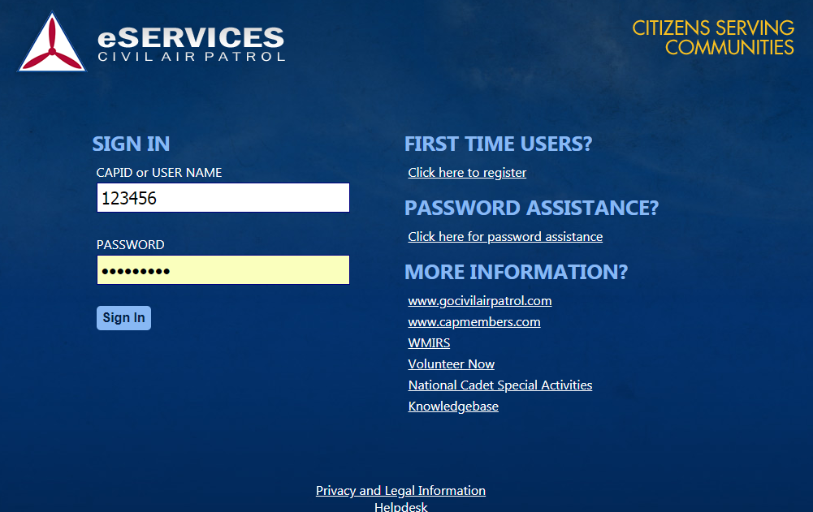

- Once logged in click on the members name in the upper right hand corner of the page and a drop down box will appear.
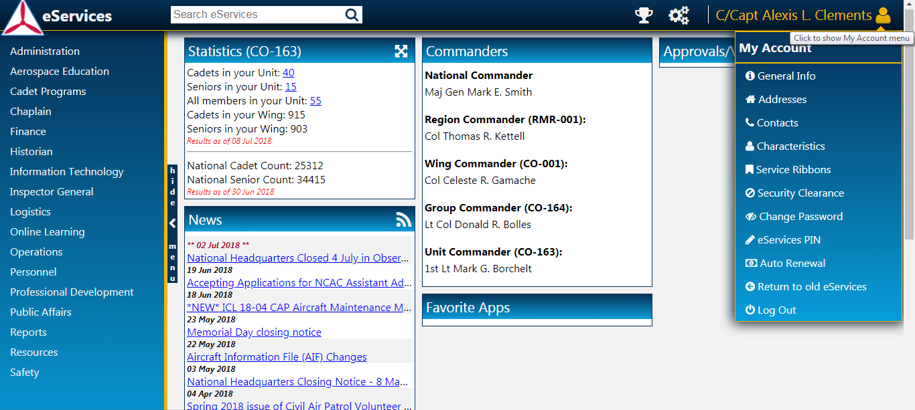
- Click on Contacts from the drop down box.
  - To Edit see step A below.
  - To Add New Contact see step B below.
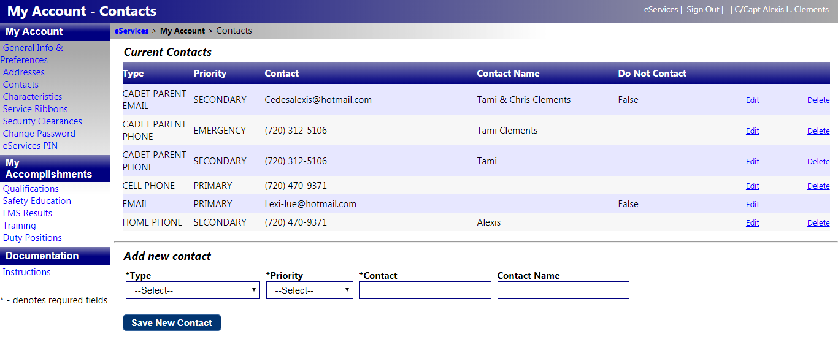
(720) 987-6543
Email@email.com
(720) 471-9852
(720) 543-2109
Email2@email.com
(720) 123-4567
- To EDIT a contact click on the Edit link next to the information you would like to modify.
  - You will then be able to update the Phone or Email address. Modify the desired information and click on the Update link.
(720) 987-6543

- To Add new contact, at the bottom of the page select (multiple contacts and contact types can be entered):
  - Type – Select from drop down box. (It is critical for alerting and messaging purposes that the contact type be correctly selected, ie if it is a member’s(cadet or senior) cell phone choose cell phone not home phone, if it is the parent’s phone choose “Cadet parent phone”)
  - Priority – Select from drop down box.
  - Contact - Enter Phone number or E-Mail address
  - Contact Name – Enter the name of the contact for the new phone or E-Mail address.
    - Then click on the Save New Contact button.
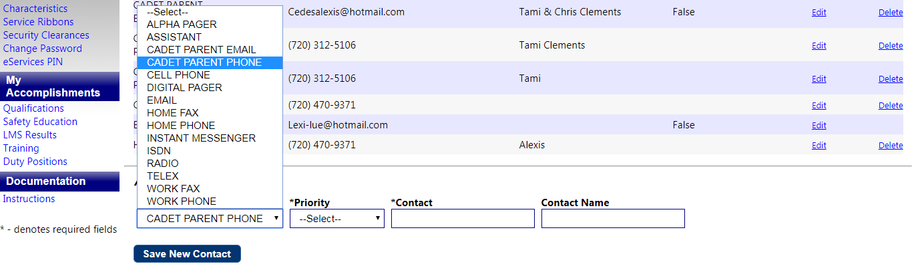
(720) 471-9852
(720) 543-2109
(720) 987-6543
Email2@email.com
(720) 123-4567
Email@email.com

